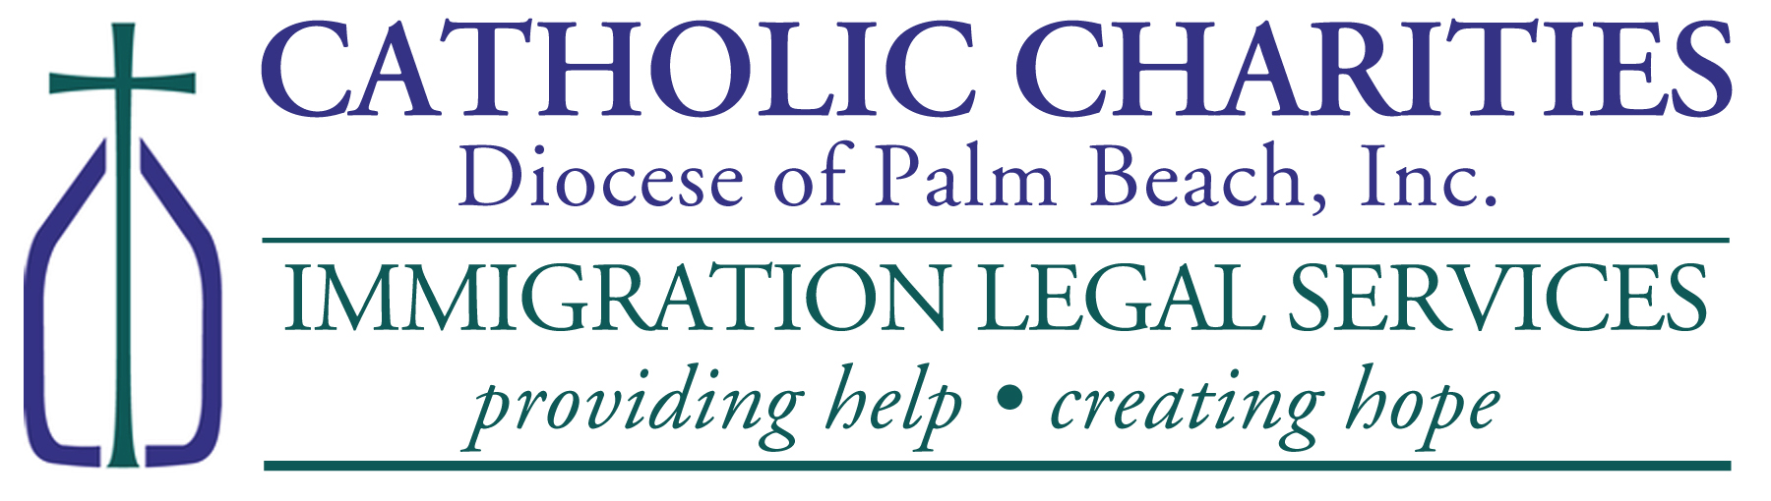
Nouvo TPS (TPS INITIAL REGISTRATION ASSISTANCE FOR HAITIANs)

WHERE: Sou randevou sèman (By Appointment Only)
Catholic Charities, St. Francis Center
100 W. 20TH Street, Riviera Beach, FL 33404
Please Call (561) 345-2031 or email lbonhomme@ccdpb.org for Appointment

PLEASE BRING TO YOUR APPOINTMENT (Sa pou ou pote nan randevou a):
- Money Orders (if requesting work authorization card):
  - $520 Work Authorization Fee Pri Kat travay ak TPS
  - $50 TPS Fee Pri TPS
  - $30 Biometric Fee
- Two (2) Passport Style Photos; 2 foto paspò
- Copy of Haitian Passport; Kopi paspò Ayisyen ou
- Copy of Visa/I-94 (if Applicable); Kopi viza ak I-94 si ou genyen yo
- Copy of Haitian Birth Certificate with English Translation; Kopi extrè achiv ou ak tradiksyonl an anglè
- Copy Of Prior TPS Approval Notice (if applicable); Kopi ansyen TPS ou si ou te genyenl
- Copy Of Current Employment Authorization Card Front and Back Kopi kat travay la
- Police Clearance Letter From County Sheriff Where You Reside; Lèt Lapolis
- Certified court records for any and all violations of law; Rapò tribinal si nesesè
- Proof of continuous Residence in USA since on or before June 3, 2024; Prèv prezans ou isit
- $310 for Catholic Charities (includes $10 for postage); Frè pou biwo a
- $30/page for any translation necessary. Frè pa paj pou tradiksyon si nesesè

Deadline to register is February 3, 2026! Ou dwe fè aplikasyon an avan 3 fevrier 2026.

