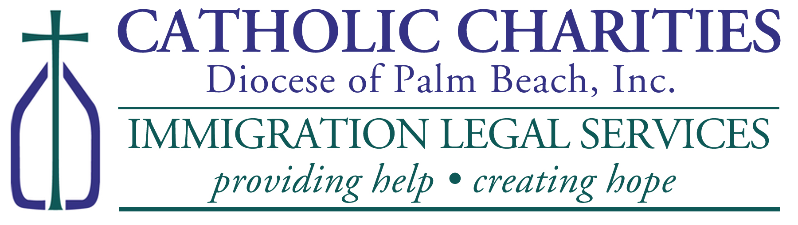
Renouvèlman TPS (TPS RE-REGISTRATION ASSISTANCE FOR HAITIANs)

WHERE: Sou randevou sèman (By Appointment Only)
Catholic Charities, St. Francis Center
100 W. 20TH Street, Riviera Beach, FL 33404
Please Call (561) 345-2031 or email lbonhomme@ccdpb.org for Appointment

PLEASE BRING TO YOUR APPOINTMENT (Sa pou ou pote nan randevou a):
- Money Orders (if requesting work authorization card):
  - $520 Pri Kat travay
- $30 Biometric Fee
- Two (2) Passport Style Photos; 2 foto paspò
- Copy of Haitian Passport; Kopi paspò Ayisyen ou
- Copy of Visa/I-94 (if Applicable); Kopi viza ak I-94 si ou genyen yo
- Copy of Haitian Birth Certificate with English Translation; Kopi extrè achiv ou ak tradiksyonl an anglè
- Copy Of Prior TPS Approval Notice (if applicable); Kopi ansyen TPS ou si ou te genyenl
- Copy Of Current Employment Authorization Card Front and Back; Kopi kat travay la
- Police Clearance Letter From County Sheriff Where You Reside; Lèt Lapolis
- Certified court records for any and all violations of law; Rapò tribinal si nesesè
- $310 for Catholic Charities (includes $10 for postage); Frè pou biwo a
- $30/page for any translation necessary. Frè pa paj pou tradiksyon si nesesè

YOUR REGISTRATION MUST BE RECEIVED BY USCIS BEFORE August 30, 2024!
Ou dwe fè aplikasyon an avan 30 aout 2024.

