Roe v. Wade Anniversary
Public Rosary

Unite for prayer for the protection of the unborn child.
Most Reverend Gerald M. Barbarito, Bishop of Palm Beach, will speak at the Old Courthouse in West Palm Beach.

Wednesday, January 22, 2020
11 a.m.

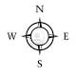

Parking Garage

P

_______________________________________4th Street_________
N. Dixie
N. Olive Ave.

Open Parking

_______________________________________ 3rd Street_________
I-95
New
Court-
house

Old
Court-
house
X

P

_______________________________________Banyan Blvd.______
Parking Garage

Driving Directions: Take I-95 to Okeechobee Blvd. Exit and travel east. Turn north onto N. Olive Ave. Turn west onto 4th St.

__________________________________________________
Okeechobee Blvd
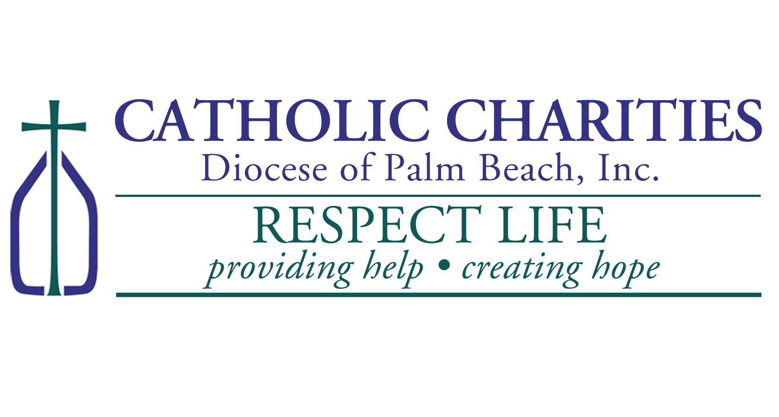
More information:
Contact the Respect Life Office 561-360-3330 or dherbst@ccdpb.org

